DATA FLOW ARCHITECTURE

1. Component Architecture Interactions
The structural context loop maps how technical requests trace from user actions down through database persistence engines. This prevents architectural tracking gaps between functional expectations and actual source deployment logic.
2. Logical System Sequences Map
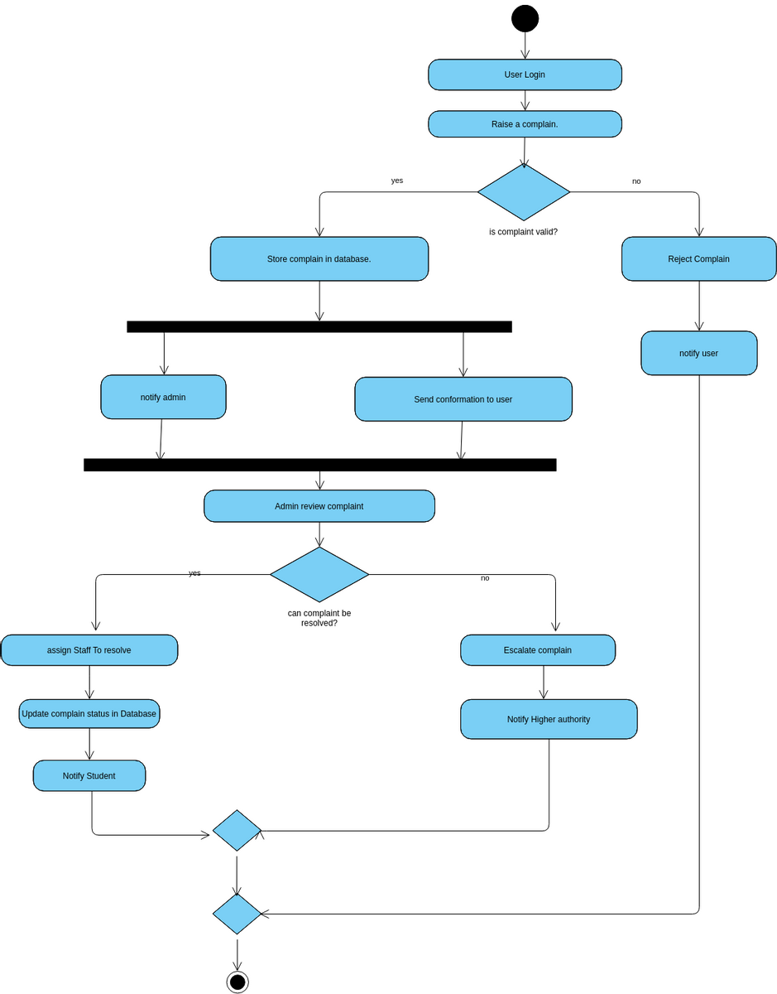

3. Data Validation Checkpoints
To avoid security issues like privilege escalation or missing fields, the system uses strict boundaries. Incoming requests hit validation checkpoints before any data maps into a permanent collection database schema. If an event fails authentication or checks look invalid, error pipelines immediately break execution threads to keep records accurate. 1

